ArtWorks CincyInk
ArtWorks CincyInk is a city wide celebration of love for the Queen City. It is an umbrella project that has several different components which are being rolled out over the course of a year.
CincyInk Poem
CincyInk poem is a crowd sourced poem inspired by the words of over 1,000 individuals who call Cincinnati home. The writing of the poem officially kicked off at the Midpoint Music Festival in 2014. At Midpoint, festival goers were invited to write words, thoughts and expressions about Cincinnati on blank postcards. Over the next several weeks postcards were available at local libraries to fill out and send to ArtWorks. All of the over 1,000 postcards were compiled and given to the poetry collective Chase Public to turn into one epic poem about the Queen City. Over the next few months, Chase Public created the poem “Seven Hills and a Queen to Name Them” a poem with 36 stanzas of love about the Queen City.
The Cincinnati Tattoo Project
The Cincinnati Tattoo project is a collaboration between ArtWorks and the artists Kurt Godhe and Kremena Todorova and is inspired by their tattoo projects in Lexington, KY and Boulder, CO. For the tattoo project, the CincyInk poem “Seven Hills and a Queen to Name Them” was divided into a series of short phrases which were crafted into 263 unique tattoos. Individuals were able to sign up to receive a tattoo free of cost although they were not guaranteed a phrase. These tattoos were all done in the same font (dante) and have the same triangular designs which represent the hills of Cincinnati. When combined all of the background designs create one secret image which is a separate tattoo for one individual.
CincyInk Installations
There are 2 types of CincyInk installations both based on the poem “Seven Hills and a Queen to Name Them.” The first are large samples of written text which blanket the Central Business District. There are 17 total installations (1 large scale sculpture, 2 light based projections, 2 vinyl bus wraps, and 12 vinyl installations). The lines of the poem that are used in the installations were chosen based on location and content.
The second type of CincyInk installations are 38 mini mural posters placed around OTR and the Northern Liberties. Each poster represents one of the 36 stanzas of the poem (1 is the title and 1 is the whole poem). The posters are all created by local designers who were required to include at least one word from their stanza in their mini mural. These posters will be available for purchase through our website later this summer.
Both installations are part of the CincyInk Scavenger Hunt.
What’s still in the works
A short documentary film is being made of the entire project from start to finish. This will likely be screened in November in conjunction with a celebration to commemorate the completion of this large scale project. There is a possibility of a book created about the project but that is still very much in the exploratory phase.

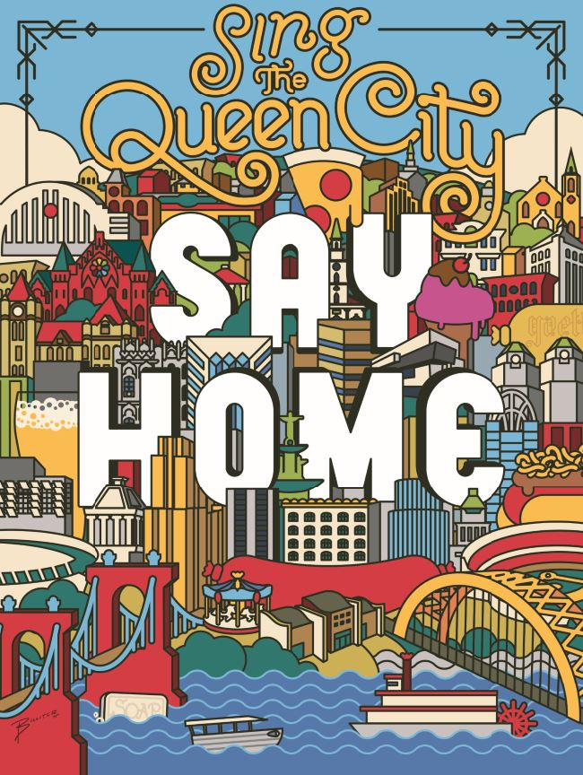
Artist: James Billiter, LPK
Location: 12&Vine on the 12th side of Taste of Belgium, across from 12/v Mica
Based on the last line of the CincyInk Poem: Sing the Queen City. | Say home. | Coast the long cut. | Cross that bridge.
This is one of my favorite mini murals. It is designed by James Billiter of LPK who was a partner in this project. This mural illustrates the final line of the CincyInk poem which says “Sing the Queen City. Say home. Coast the long cut. Cross that bridge.” The largest words that are most prominent in this mini mural are “Say Home” and when I look at this mural, I see a lot of things that remind me of my home (Cincinnati). What do you see that celebrates some of the unique aspects of Cincinnati? This is what CincyInk is all about, celebrating our Queen City and all that makes it unique. It is a love letter to our City. What is one thing that you love about Cincinnati that you might add to this mural?
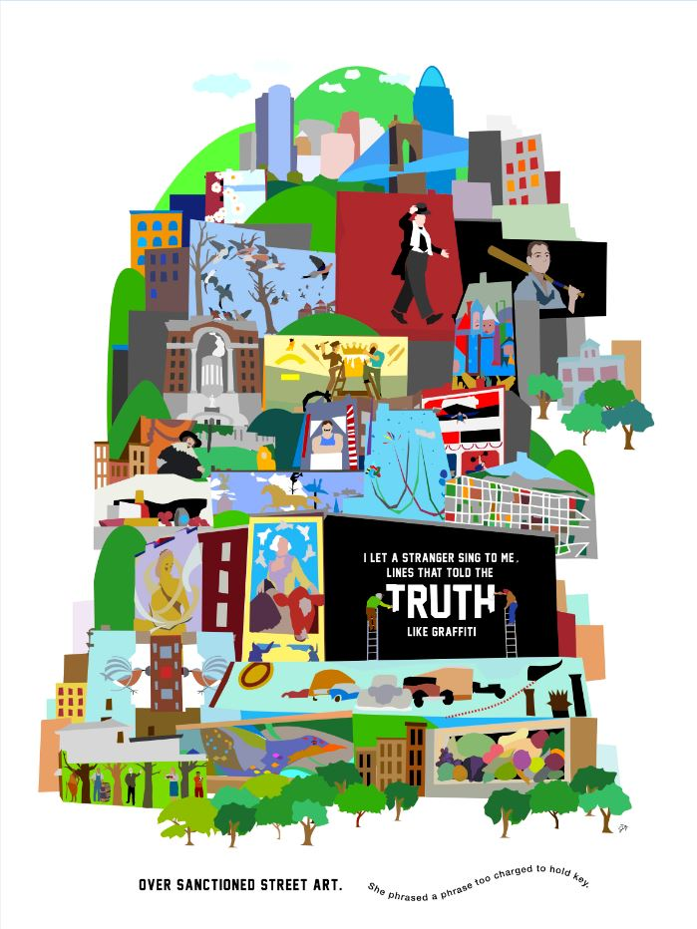
Artist: Jake Gerth, Frameshop
Location: Jackson side of ArtWorks
Based on line: I let a stranger sing to me, | lines that told the truth like graffiti | over sanctioned street art. | She phrased a phrase too charged to hold key.
I want to point out this mini mural which is part of ArtWorks CincyInk project. CincyInk is a city wide celebration of love for the Queen City that started with an epic 37 stanza poem called “Seven Hills and a Queen to Name Them.” This poem was written by the poetry collective Chase Public who compiled stories, thoughts and words of over 1,000 Cincinnatians. There are 38 of these mini murals hidden around Over-the-Rhine, each based on a stanza of the poem, and we’ll be passing some on our tour today. If you see one, point it out! You can snap a photo and tag it #CincyInk. We’ll be looking at my favorite mural in more detail towards the end of the tour.

